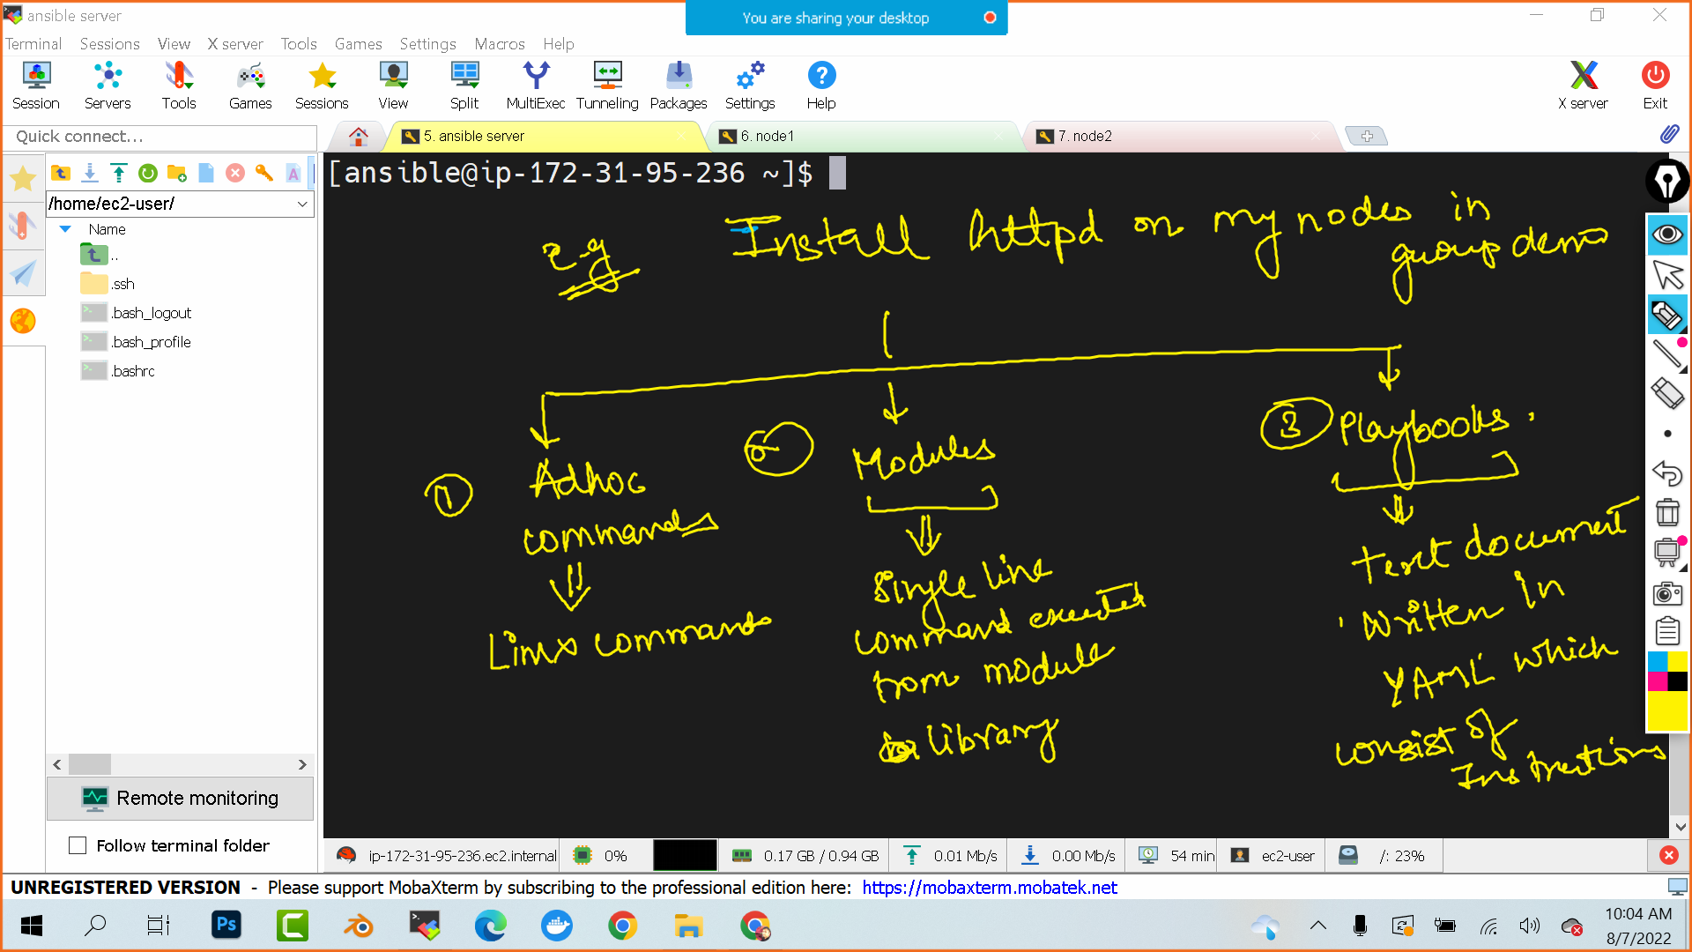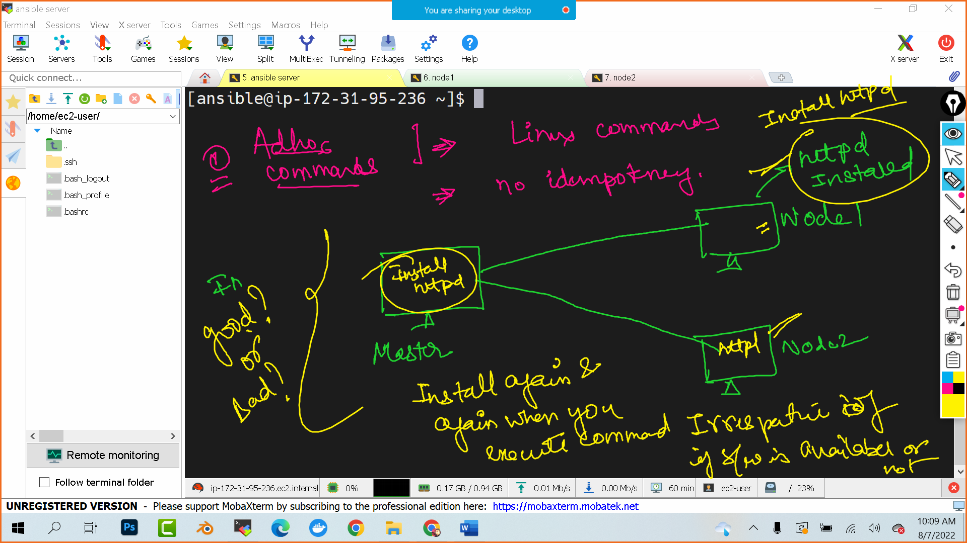

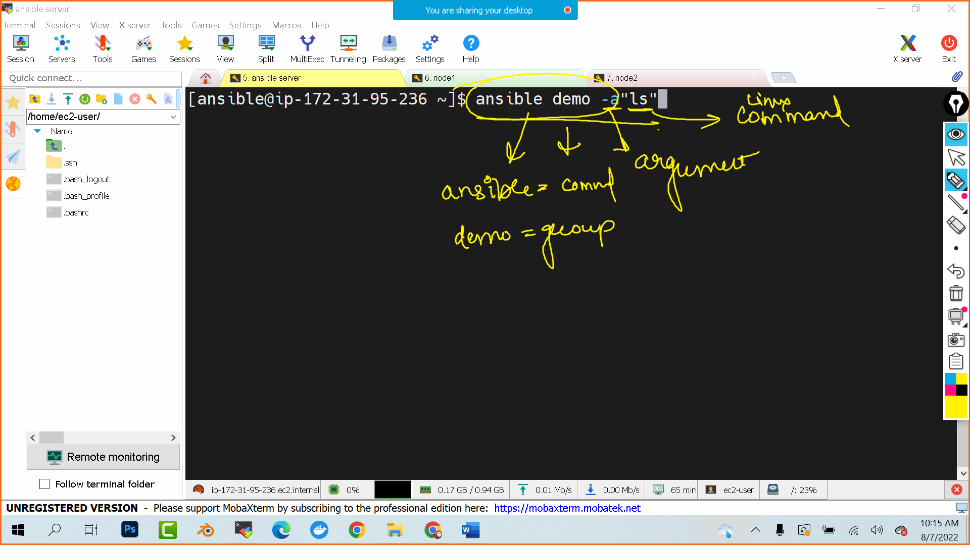

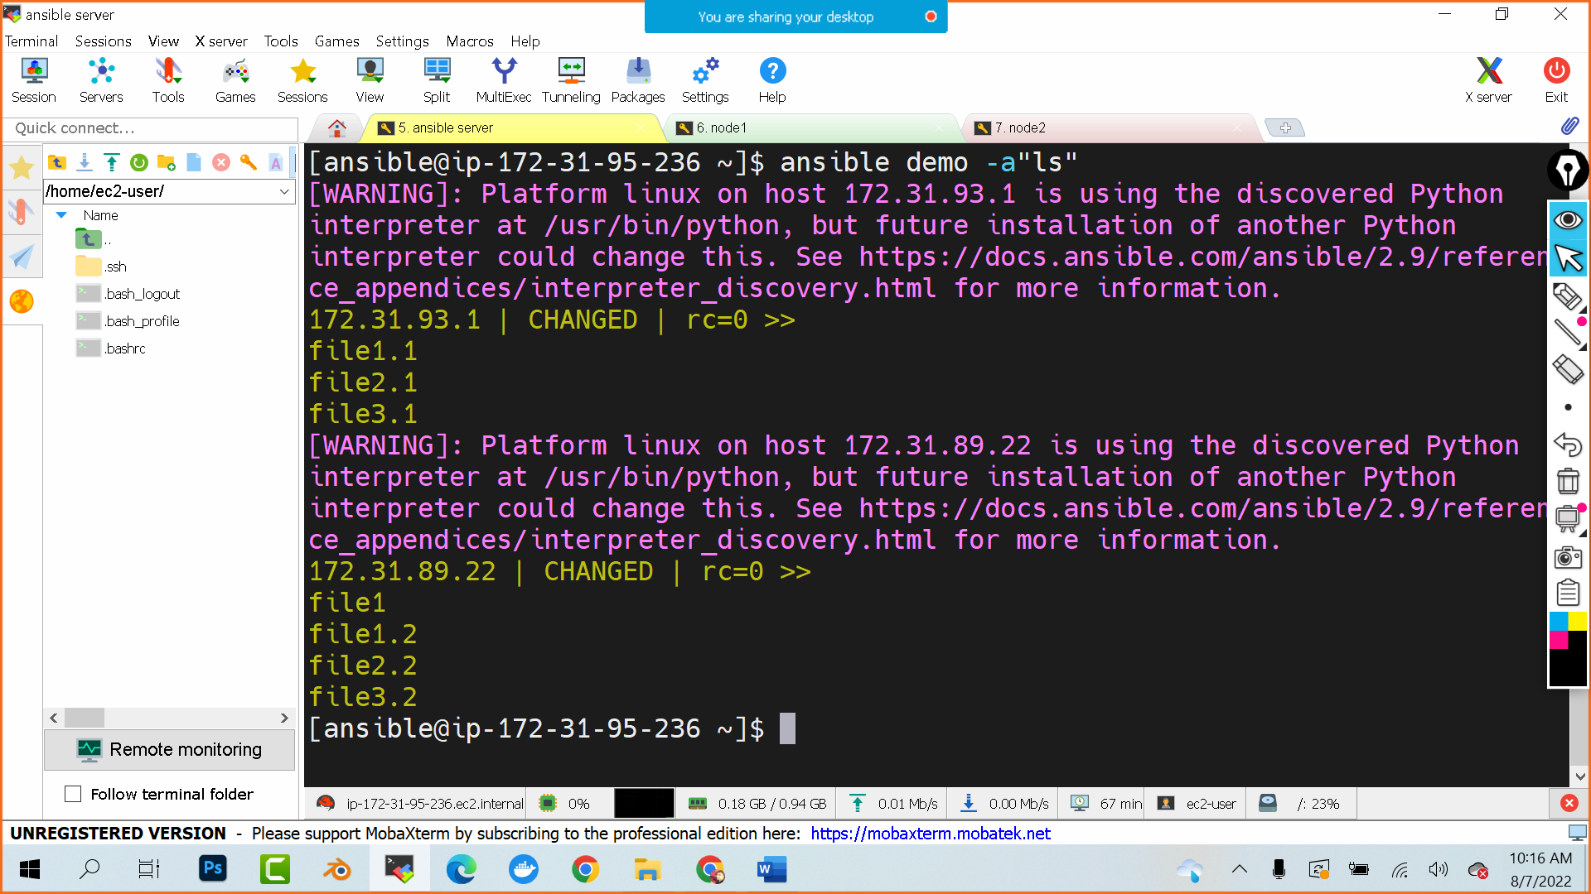

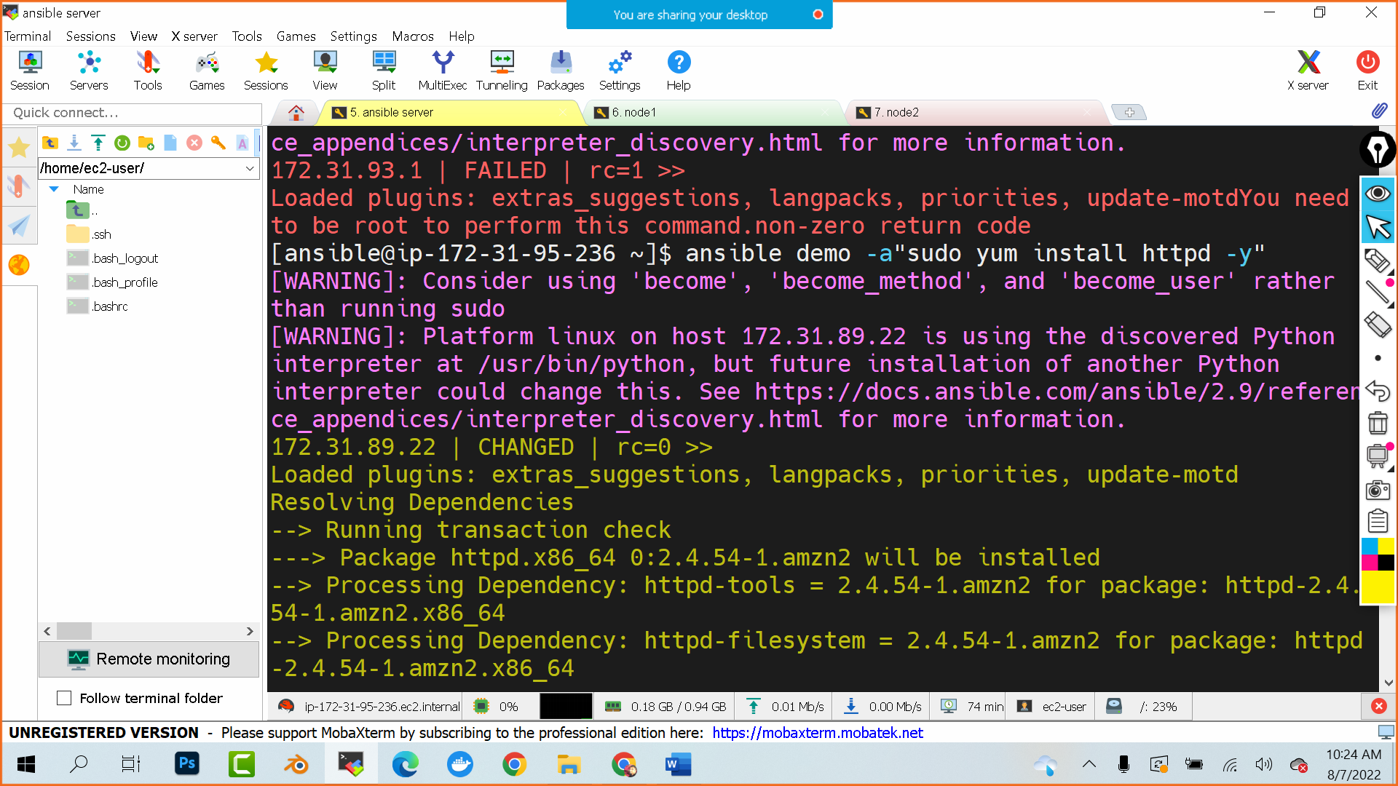

Go to node1 and use which httpd and see if https is installed or not

Go to node2 and use which httpd and see if https is installed or not

To remove httpd:

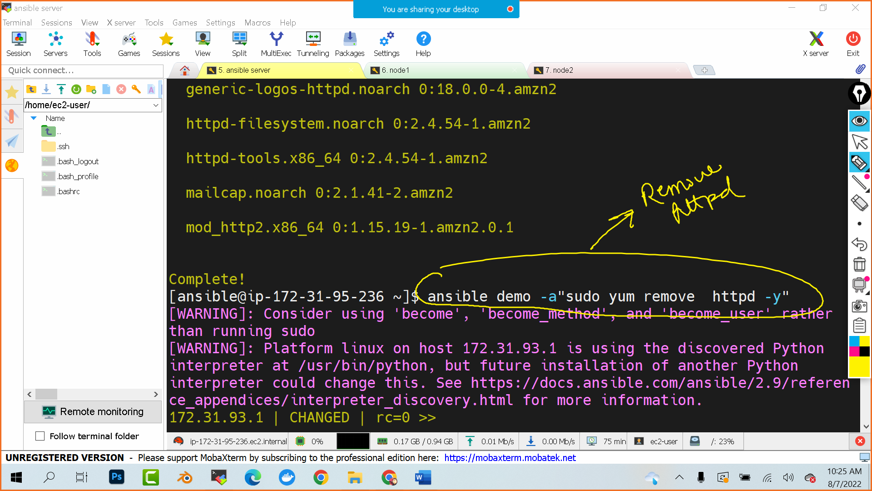

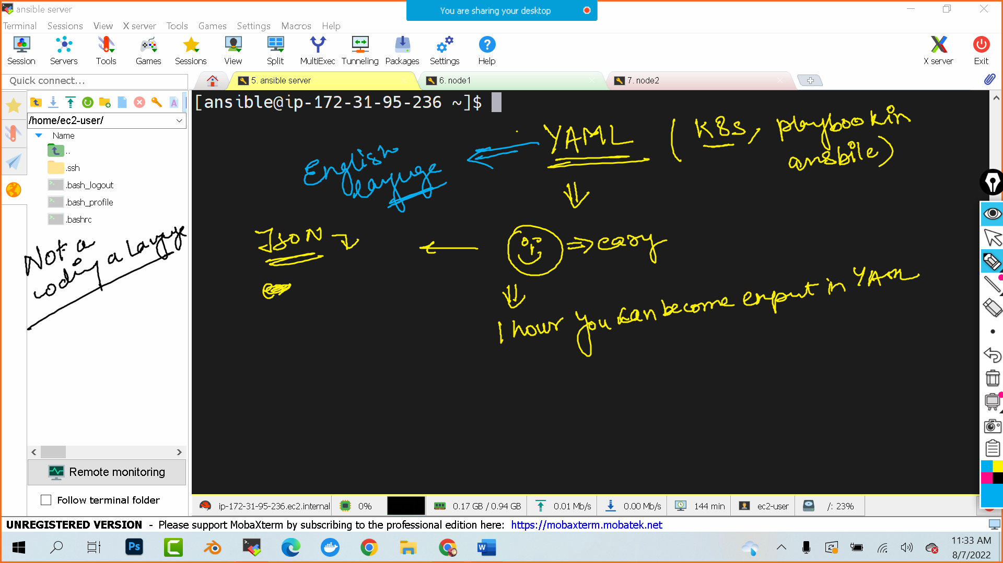

YAML

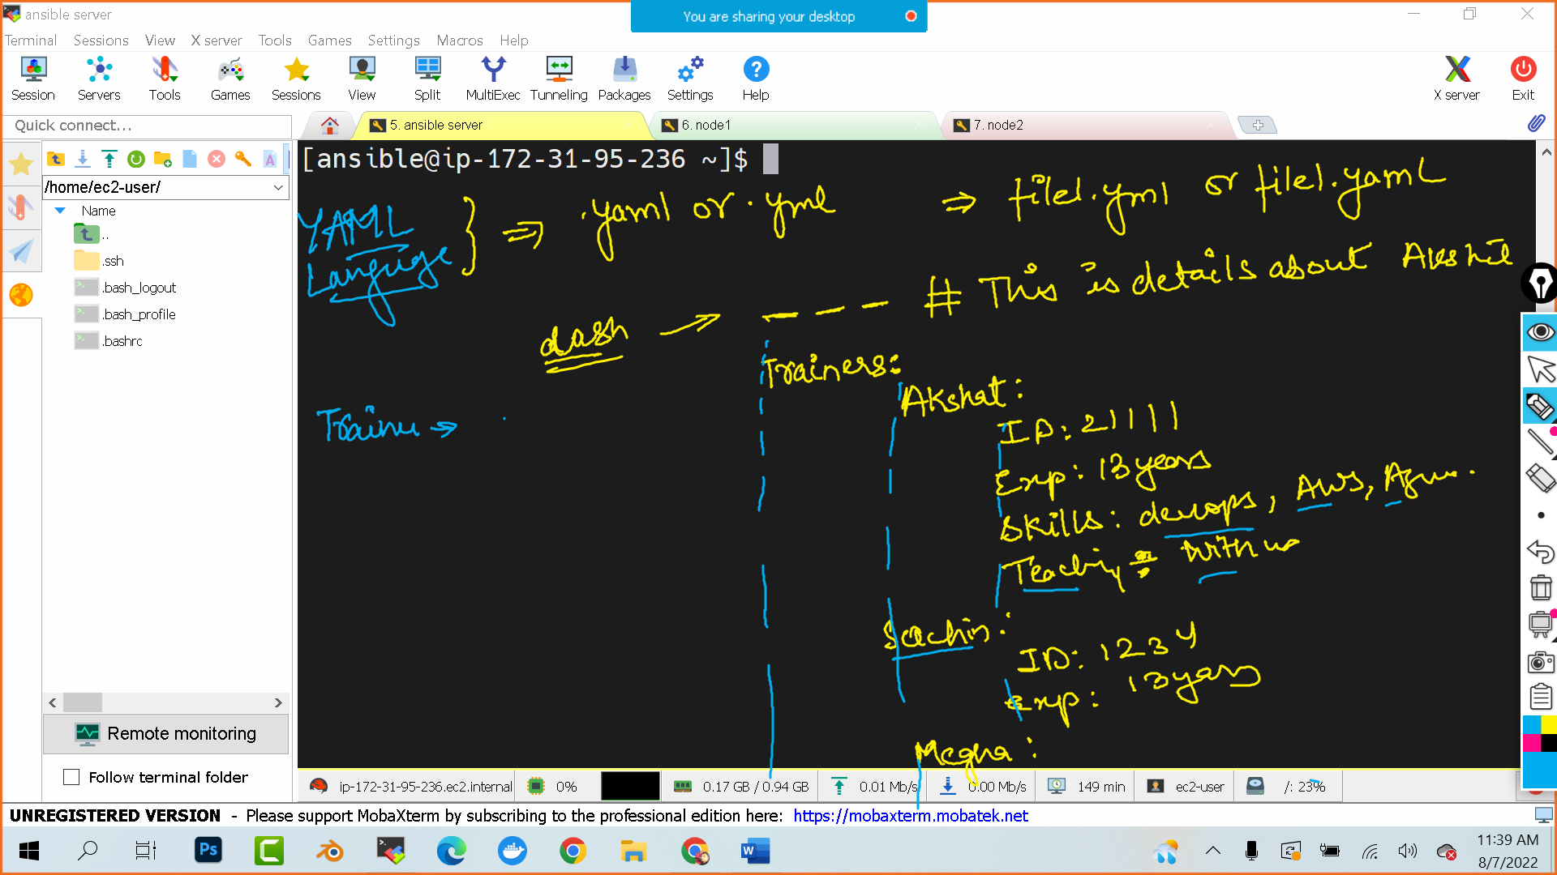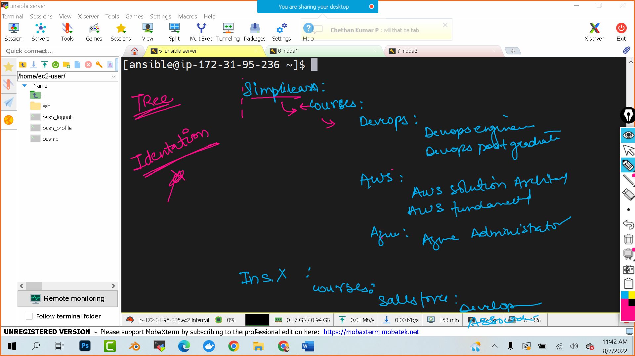

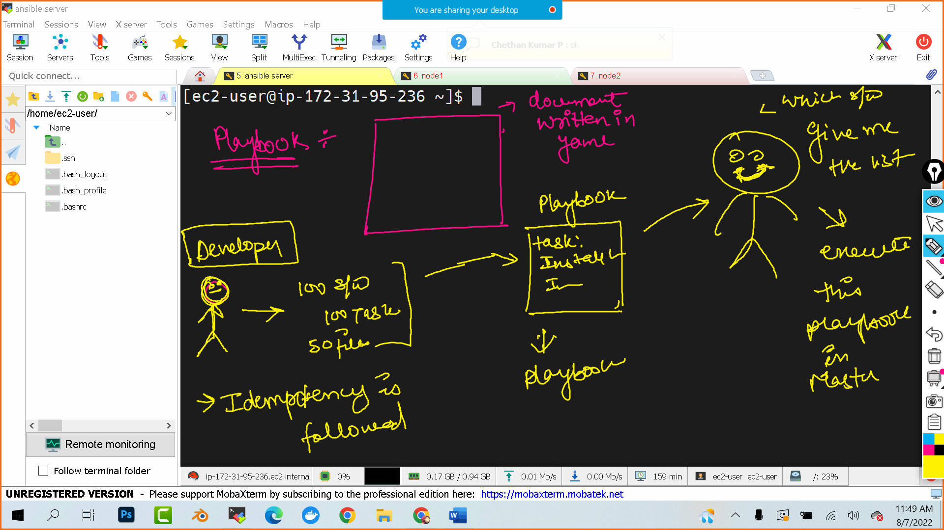

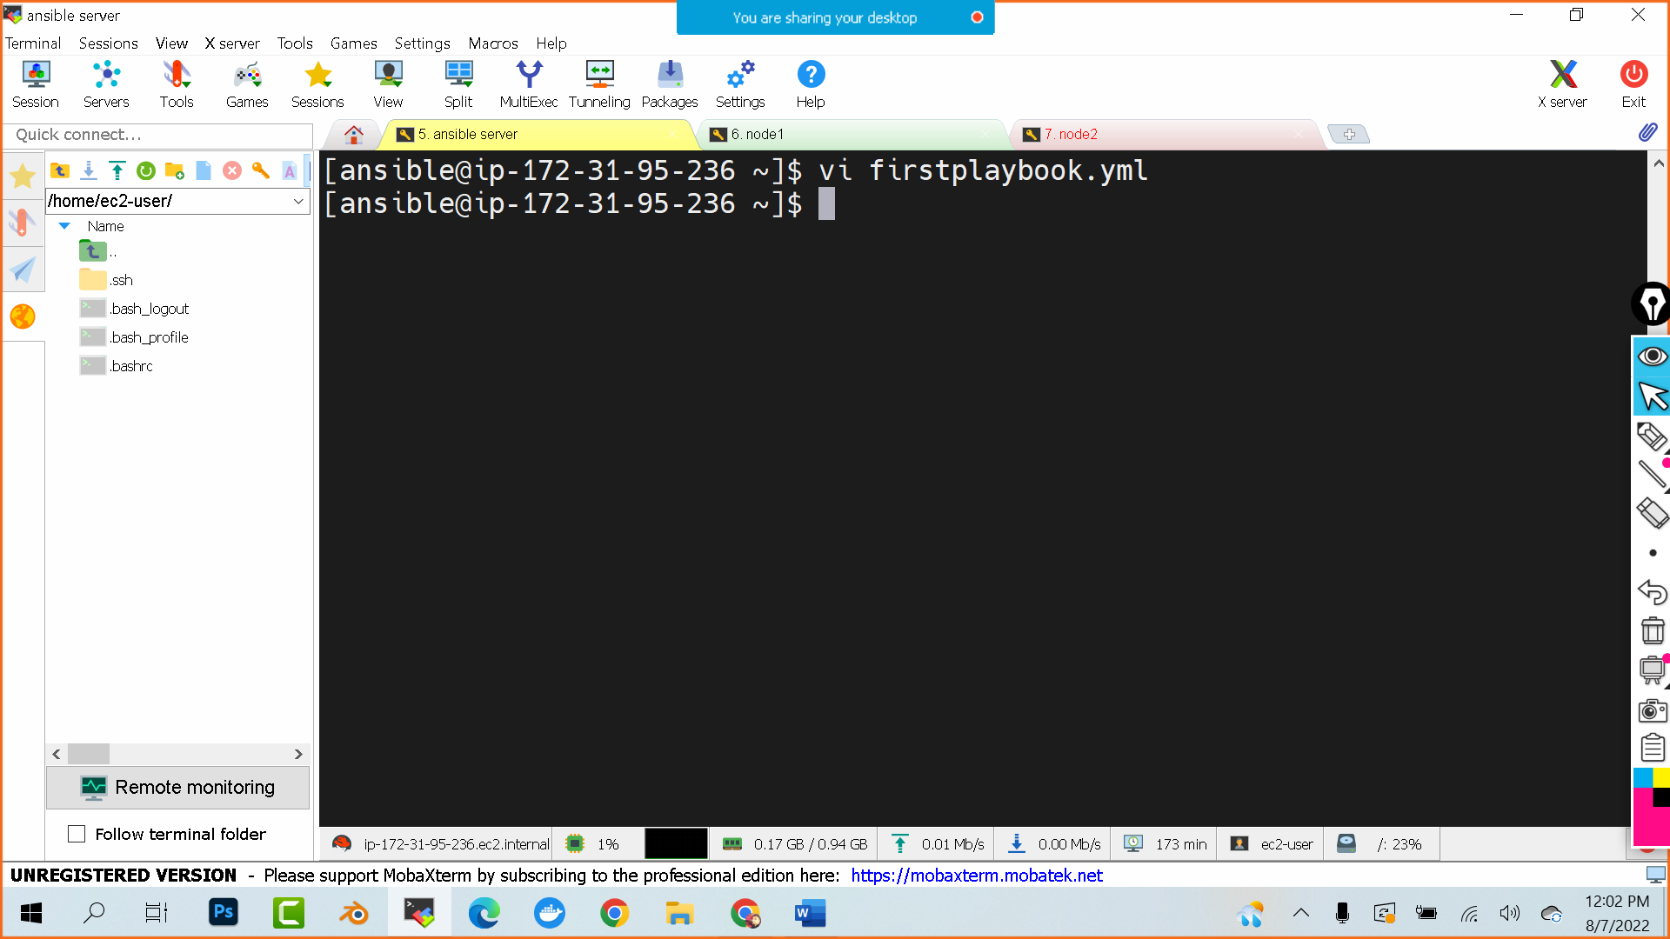

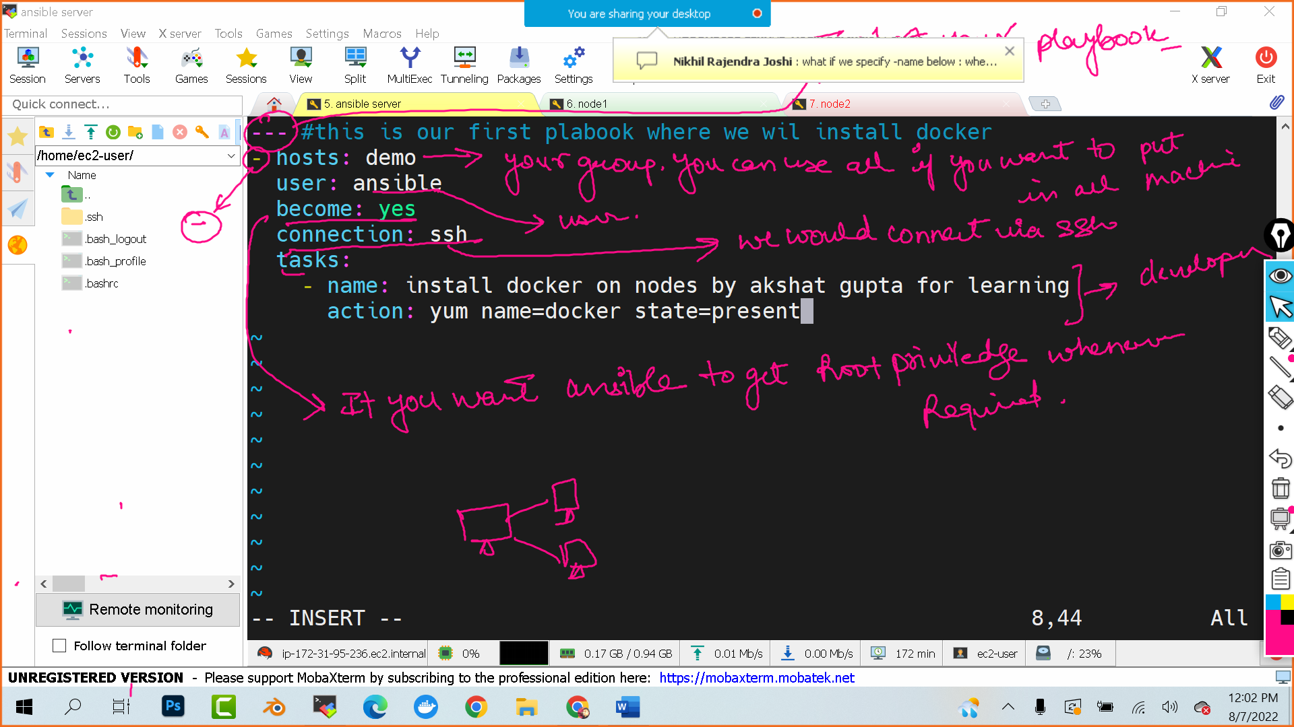

Ansible-playbook firstplaybook.yml

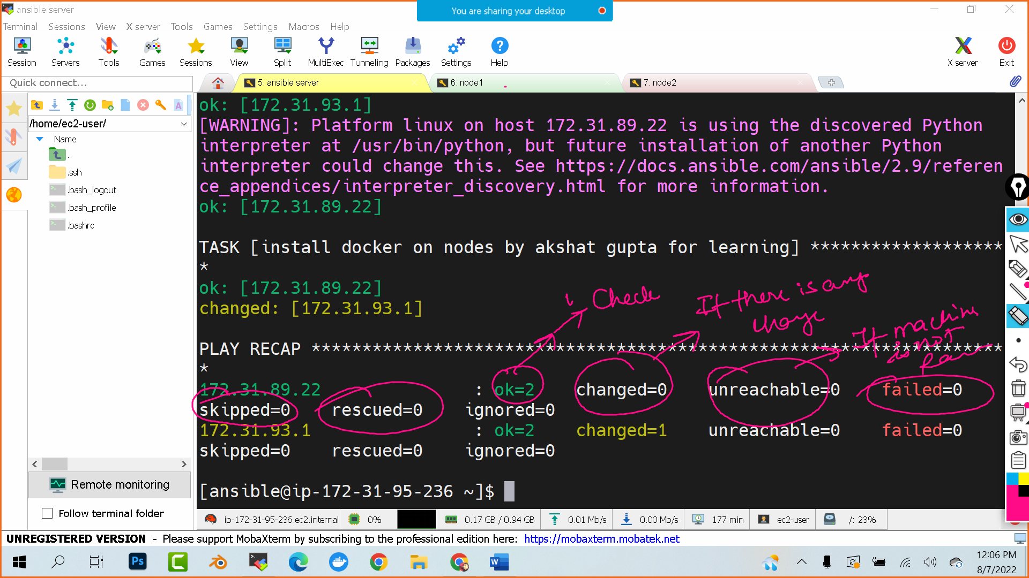

Go to node 1 and node 2 and check

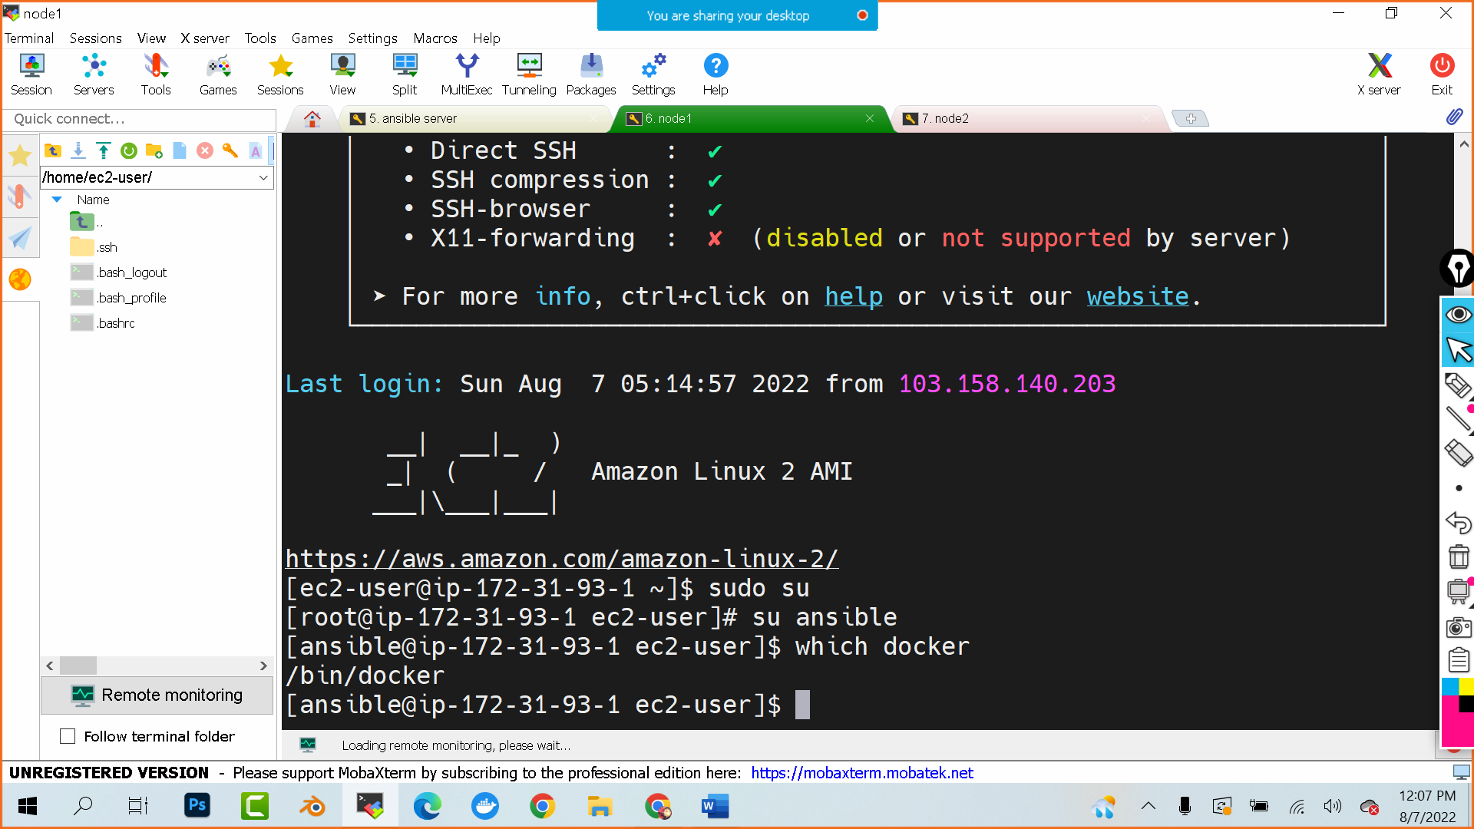

If you want to delete the docker and install git what change in playbook you will do ?

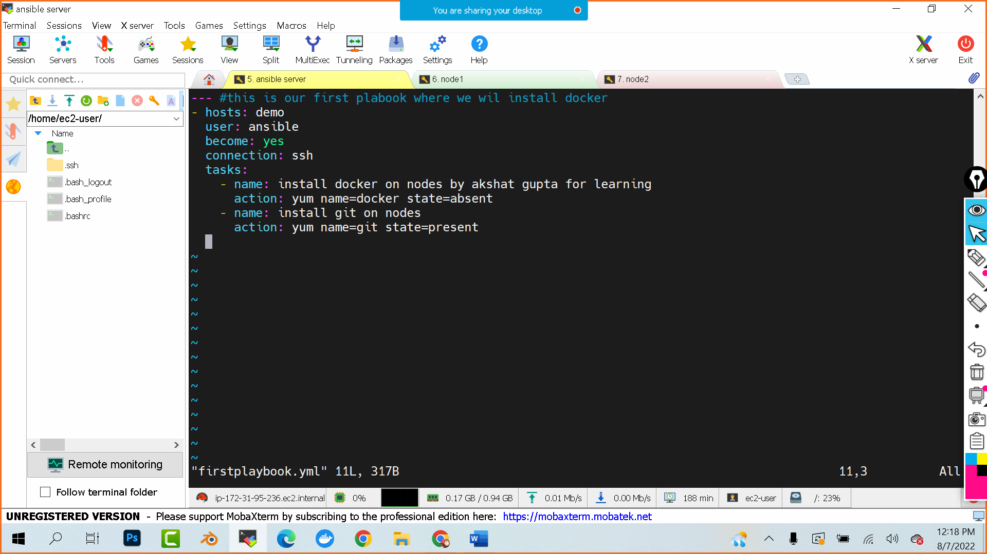

--- #this is our first plabook where we wil install docker

- hosts: demo

user: ansible

become: yes

connection: ssh

tasks:

- name: install docker on nodes by akshat gupta for learning

action: yum name=docker state=absent

- name: install git on nodes

action: yum name=git state=present

If you want to copy and file from my ansible server to nodes?

>> we will first create a file in ansible server

cat > index.html

hello devops

(press ctrl D to exit)

Now I want to copy this file in nodes via playbook

pwd #it will give me the working directory

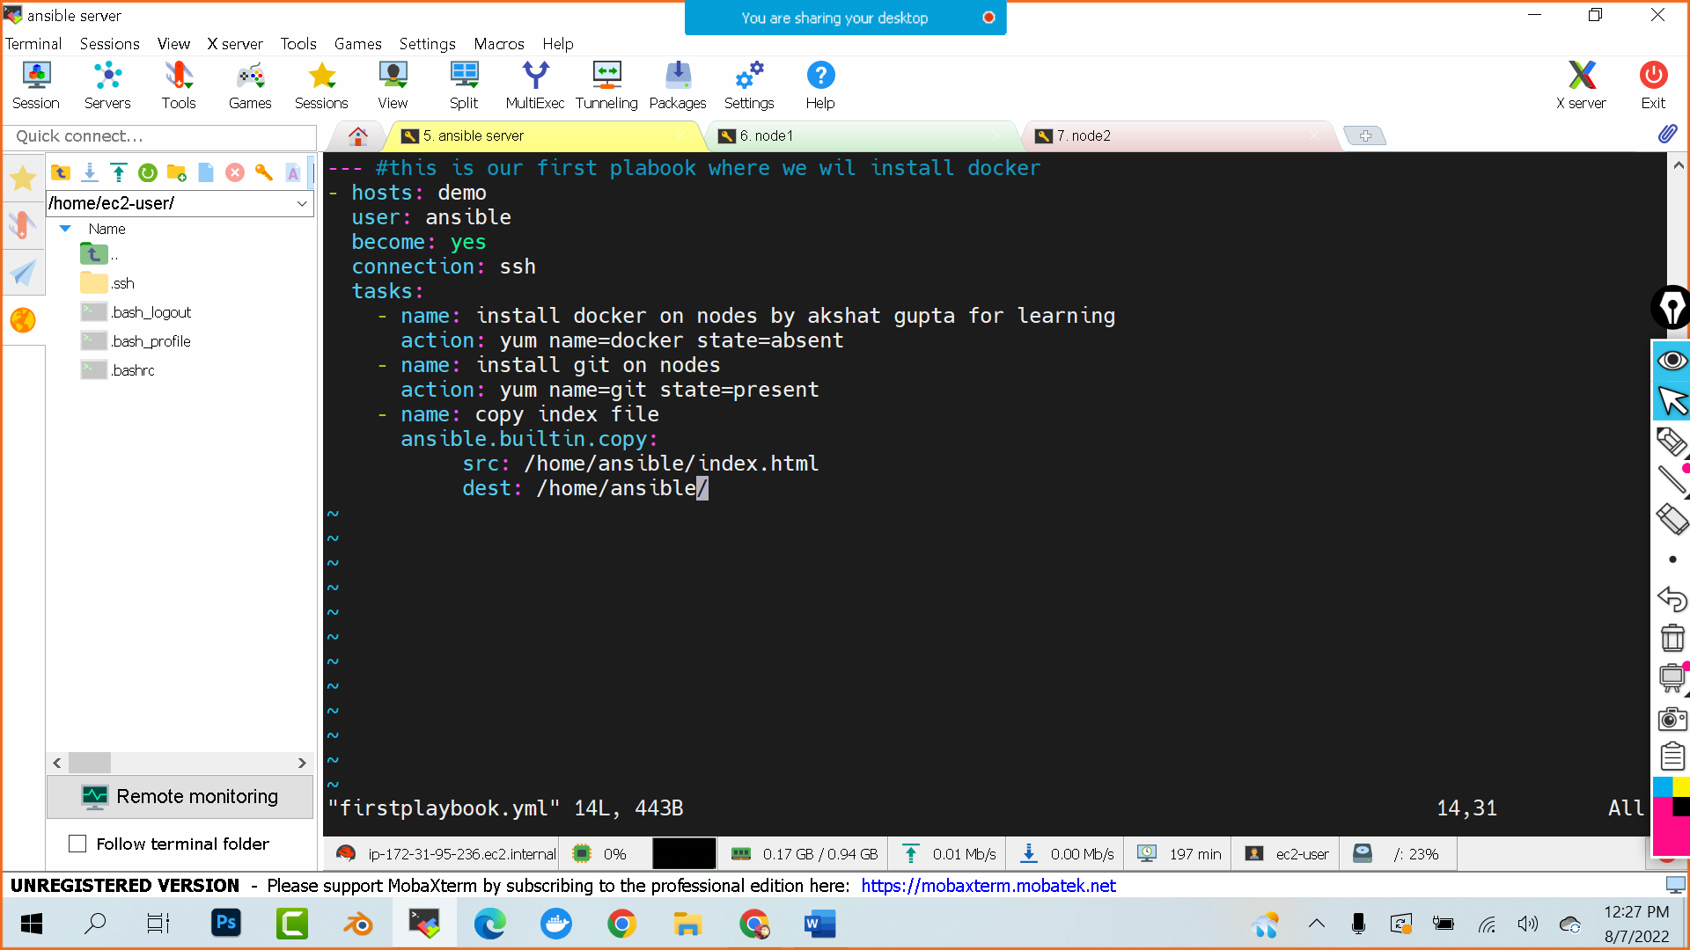

--- #this is our first plabook where we wil install docker

- hosts: demo

user: ansible

become: yes

connection: ssh

tasks:

- name: install docker on nodes by akshat gupta for learning

action: yum name=docker state=absent

- name: install git on nodes

action: yum name=git state=present

- name: copy index file

ansible.builtin.copy:

src: /home/ansible/index.html

dest: /home/ansible/

~

Create a directory

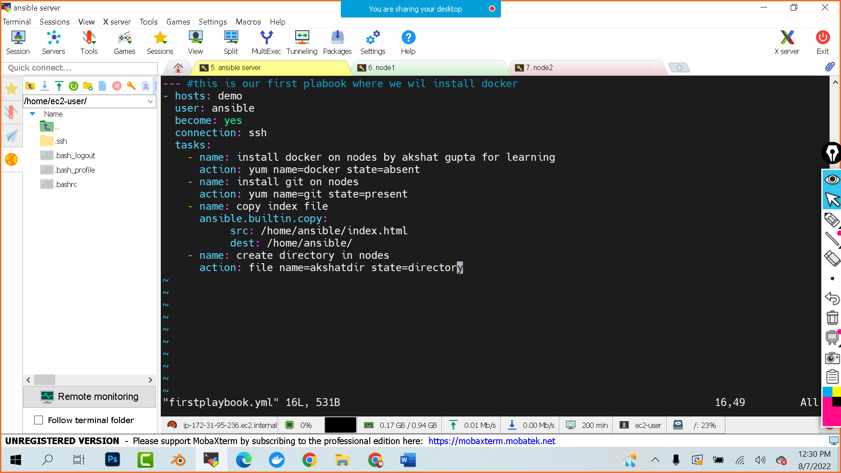

--- #this is our first plabook where we wil install docker

- hosts: demo

user: ansible

become: yes

connection: ssh

tasks:

- name: install docker on nodes by akshat gupta for learning

action: yum name=docker state=absent

- name: install git on nodes

action: yum name=git state=present

- name: copy index file

ansible.builtin.copy:

src: /home/ansible/index.html

dest: /home/ansible/

- name: create directory in nodes

action: file name=akshatdir state=directory

MODULES : (single command based instructions)

ansible demo -b -m yum -a"pkg=docker state=present"

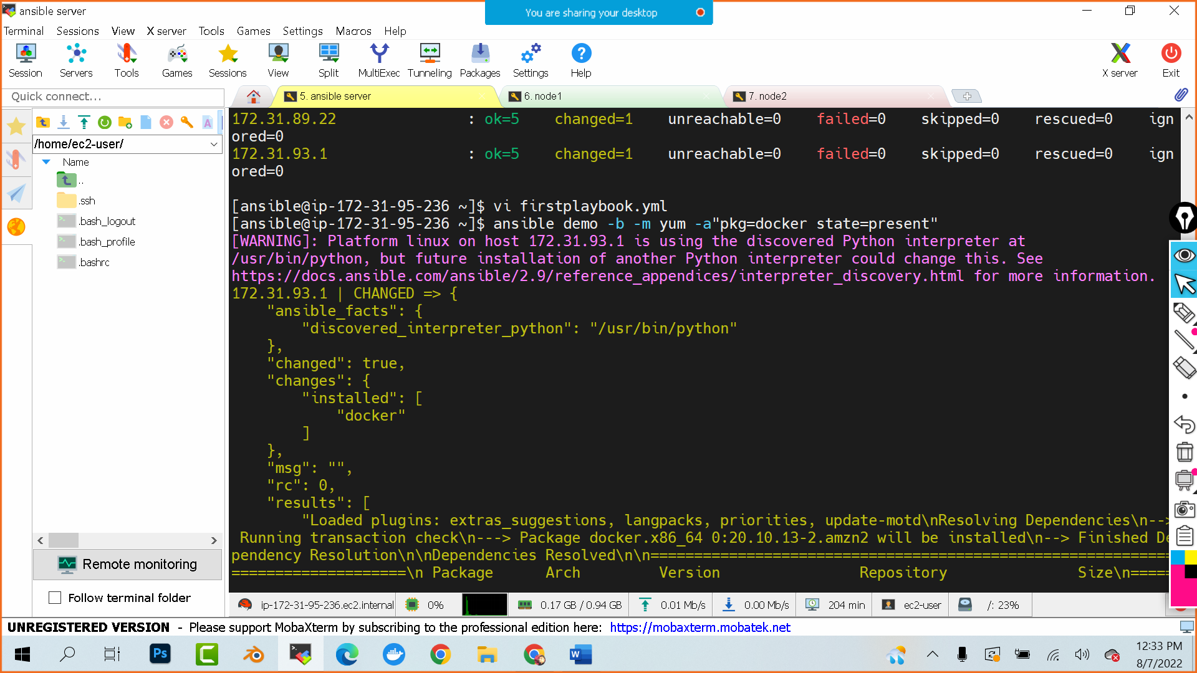

Launch a website using ansible playbook

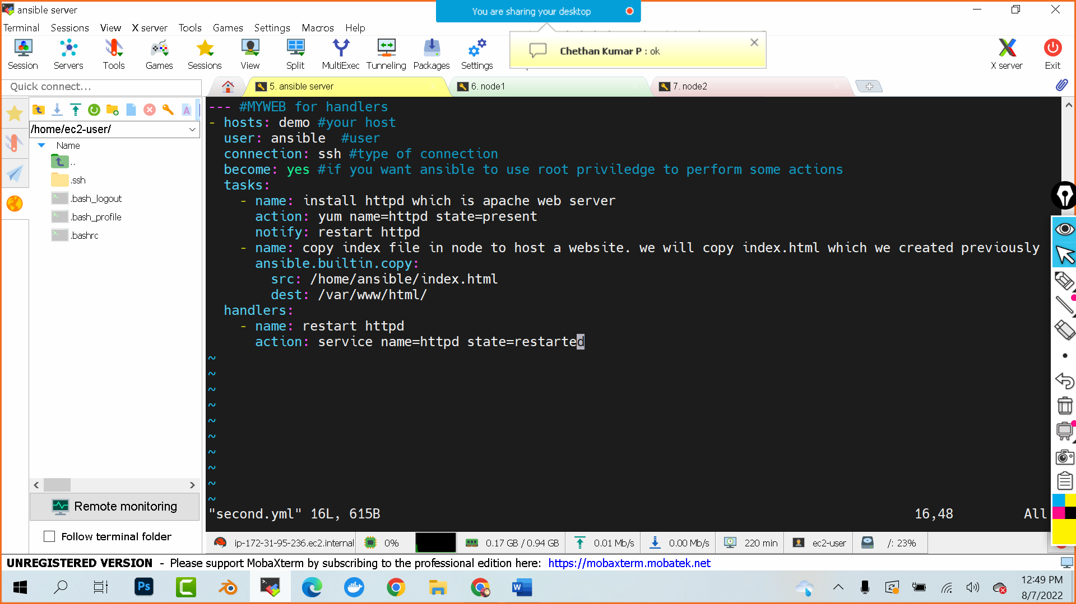

--- #MYWEB for handlers

- hosts: demo #your host

user: ansible #user

connection: ssh #type of connection

become: yes #if you want ansible to use root priviledge to perform some actions

tasks:

- name: install httpd which is apache web server

action: yum name=httpd state=present

notify: restart httpd

- name: copy index file in node to host a website. we will copy index.html which we created previously

ansible.builtin.copy:

src: /home/ansible/index.html

dest: /var/www/html/

handlers:

- name: restart httpd

action: service name=httpd state=restarted

